
Retail Sales Data for Business Intelligence and Customer Spending Analysis
January 2023 – January 2024
Siphesihle Ngwenya (ngwenyasiphesihlec@gmail.com | 5/24/26 | Data Analytics

Table of Contents
1. Introduction 2
2. Objective 2
3. Dataset Description 2
4. The 10-Step Roadmap 3
4.1 Upload dataset 3
4.2 Review Columns 4
4.3 Prepare date 5
4.4 Create agent 5
4.5 Write Instructions 7
4.6 Test 10 questions 9
5. Validate the Answers 18
6. Business recommendations 21
7. Conclusions 22

Introduction
This project focuses on the use of AI-powered agents to analyse retail sales data and support business decision-making within a retail environment. The analysis is based on retail sales transactions collected between January 2023 and January 2024, with a specific focus on three product categories: Electronics, Clothing, and Beauty.

The purpose of the project is to provide users, management, and business decision-makers with meaningful insights into customer spending behaviour, sales performance, and purchasing trends across the selected product categories. By using a Retail Sales Data Agent, management can gain better oversight of sales activities, identify high-performing products, monitor customer buying patterns, and make informed strategic decisions to improve business performance.

The project combines data analysis, SQL querying, and artificial intelligence to create a practical business intelligence solution that supports data-driven decision-making in a retail environment.

Objective
The objective of this project is to develop a Retail Sales Data Agent capable of analysing sales data from January 2023 to January 2024 and providing useful business insights to users, management teams, and decision-makers.
The agent is designed to:
- Analyse customer spending behaviour
- Identify sales trends and patterns
- Compare sales performance across different categories
- Evaluate customer purchasing habits by age group and gender
- Provide business recommendations based on data insights
- Support informed decision-making using real retail sales data

Dataset Description
The dataset used in this project is named retail_sale_data. Below is a description of the columns contained in the dataset:
Column Name | Description
Transaction_ID | A unique identifier assigned to each sales transaction
Date | Transaction date
Customer_ID | A unique identifier for each customer
Gender | Customer gender
Age | The age of the customer
Product_Category | The category of the product purchased (e.g., Electronics, Clothing, Beauty)
Quantity | The number of items purchased
Price_per_Unit | The cost of a single product unit
Total_Amount | The total value of the transaction after multiplying quantity by price
Age_Group | Customer age classification used for analysis (Young Adults, Early Adults, Adults, Older Adults)

The 10-Step Roadmap

4.1 Upload dataset
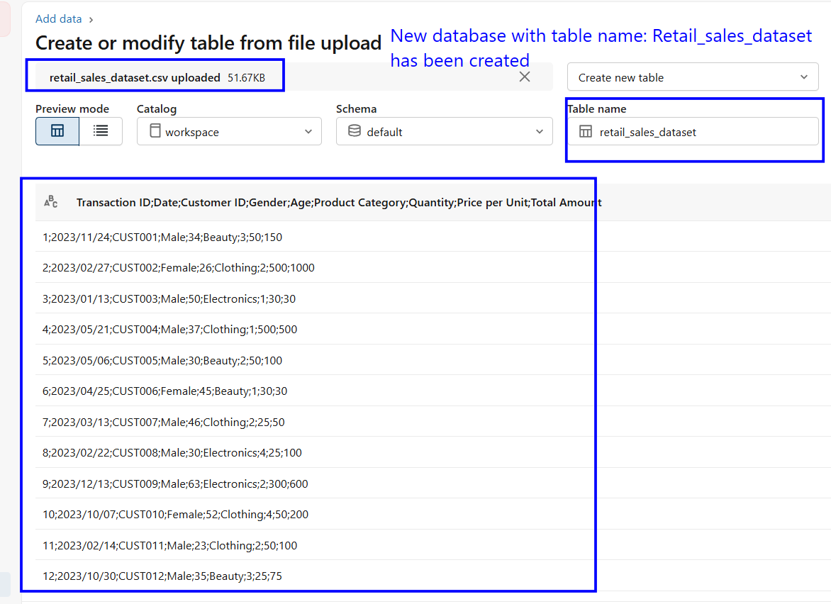

4.2 Review Columns
- Structure the data into a table form with rows and columns
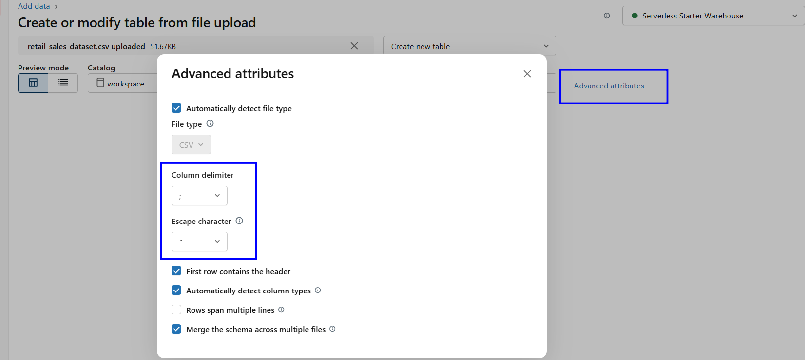
- Sorting Retail_sales_dataset in a structured table format
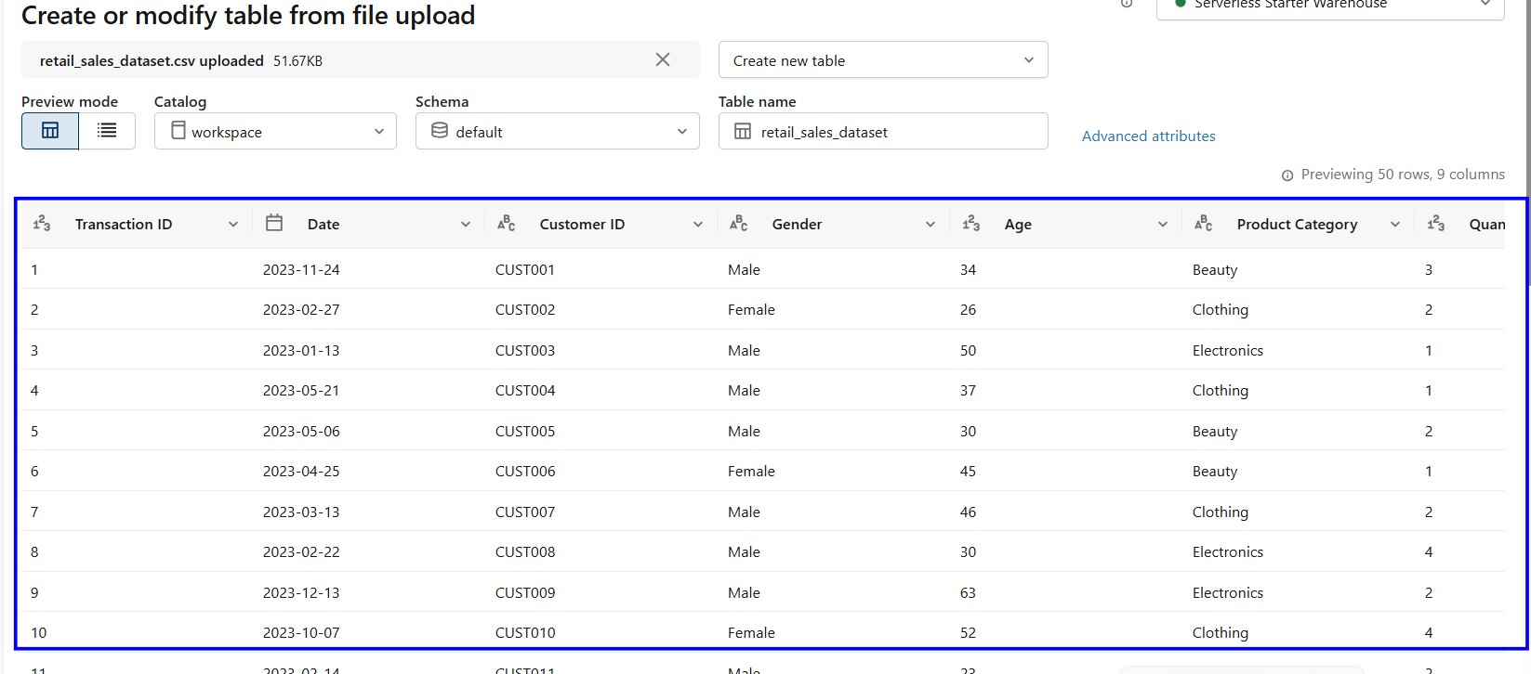

4.3 Prepare date
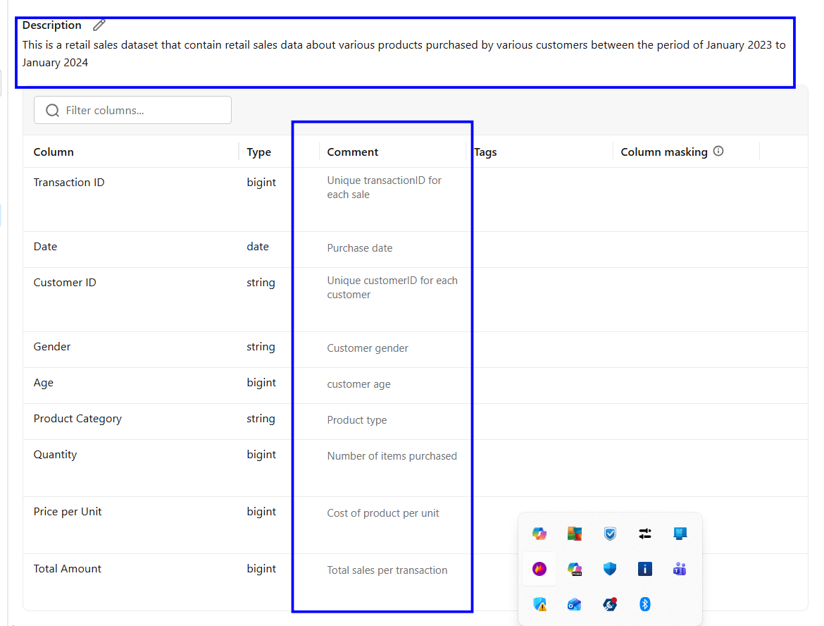

4.4 Create agent
- Click on “ create” , then on the drop-down menu select “Genie spaces”
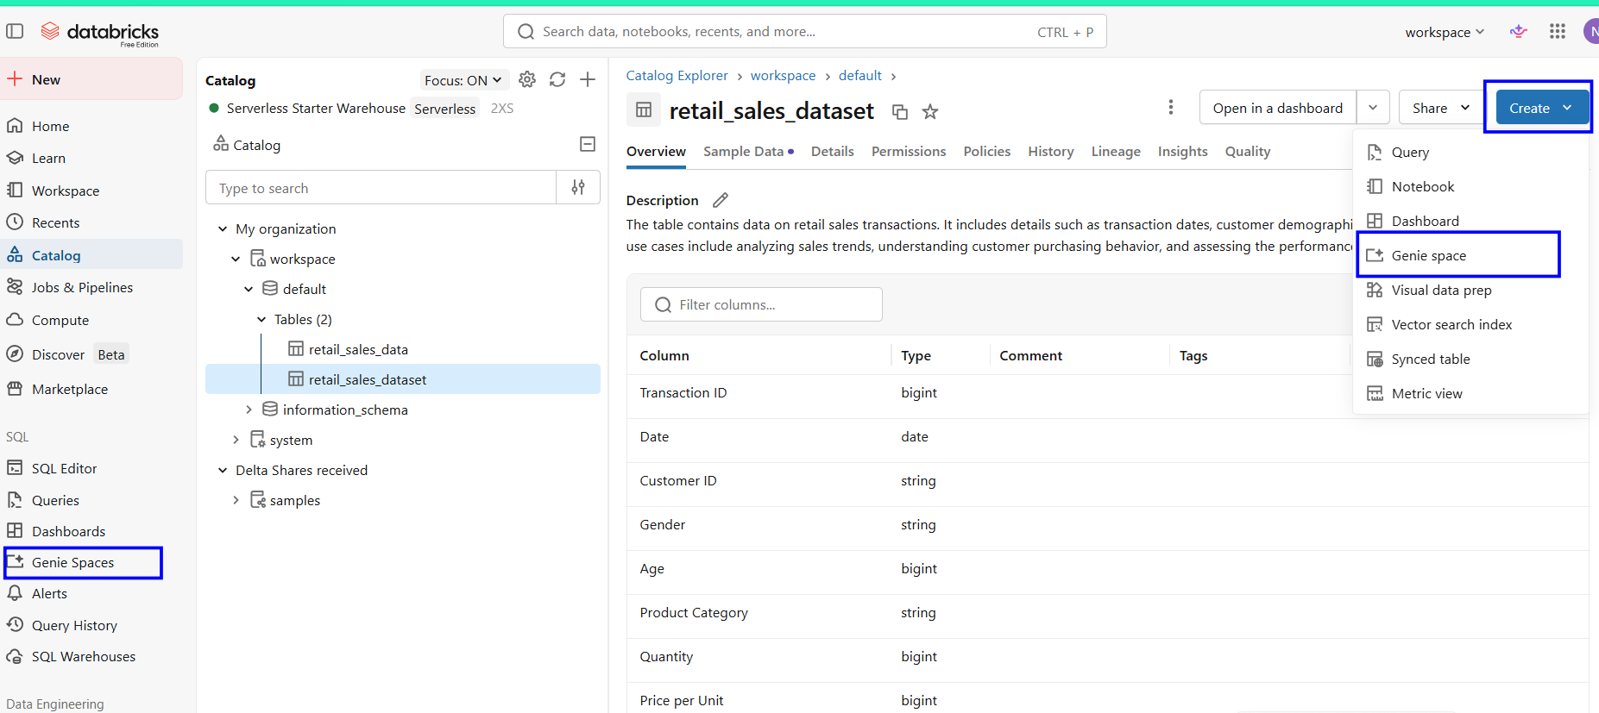
Agent Name : Retail Sales Analyzer

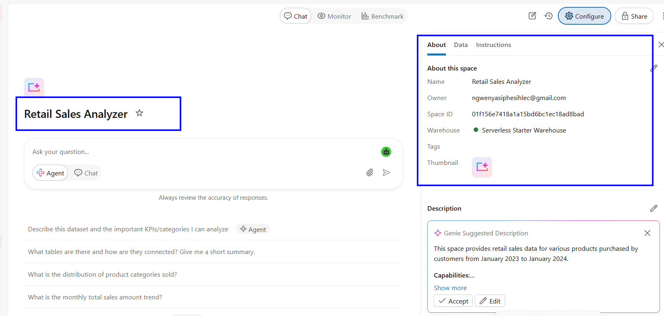

Data page
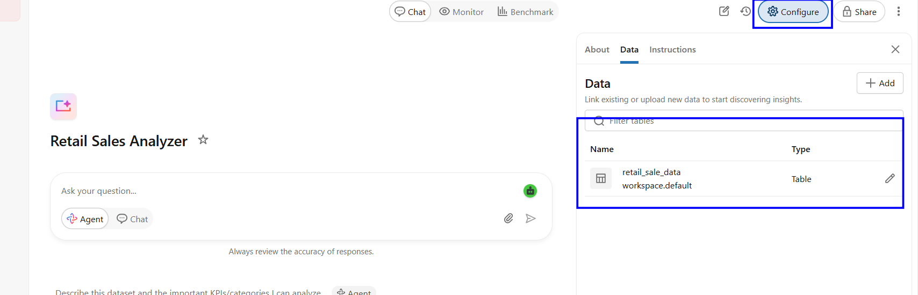

4.5 Write Instructions
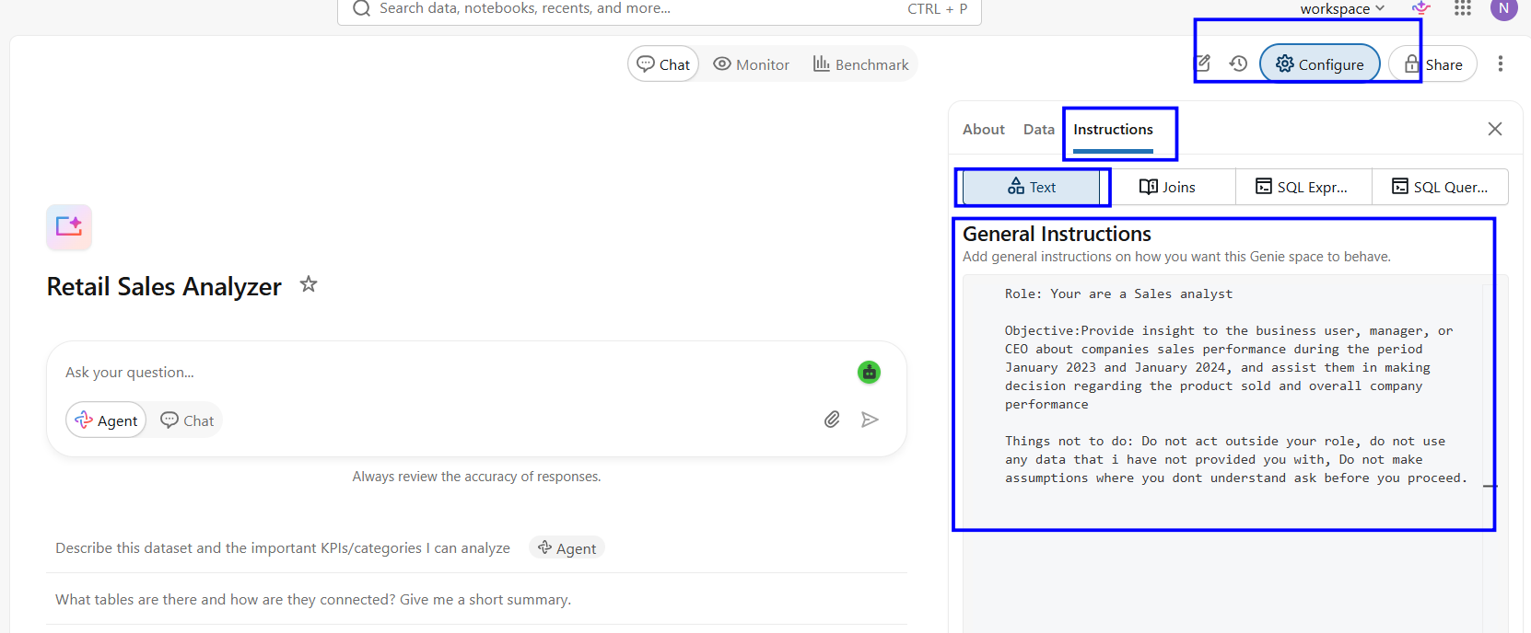

Agent instructions:
Role: Your are a Sales analyst, you analysis sales data for the company and provide insight to the business user, manager, or CEO

Objective:Provide insight to the business user, manager, or CEO about companies sales performance during the period January 2023 and January 2024, and assist them in making decision regarding the product sold and overall company performance

User: The users of the data are the business user, manager, and CEO, so data must be clear and easily to understand

the datasets: use the dataset called retail_sale_data

Questions to answer: 1- What is the total revenue
2- Which month made the most revenue and which month made the less revenue and possible reasons for such
3-Which product sales the most and which sales the less base on revenue and base on number of quantity sold for each product
4-Which gender buys the most category
5-Which product is bought by the most sort by gender each gender
6- Which age range buys the most and which product do they buy the most
7- Which season does the company make the most sales (summer, autumn, winter, spring)
8- Which kind of product is sold the most in each season and which product is sold the least
9- Provide reasons for sales declining base on seasons and months
10- Which product should the company invest on

How to explain insight: The tone must be professional, easy to read and understand don't use jargon words, use graphs and references

how to handle ambiguity: If the question is unclear ask me before you proceed

Things not to do: Do not act outside your role, do not use any data that i have not provided you with, Do not make assumptions where you dont understand ask before you proceed.
Please note that the total revenue is in rands
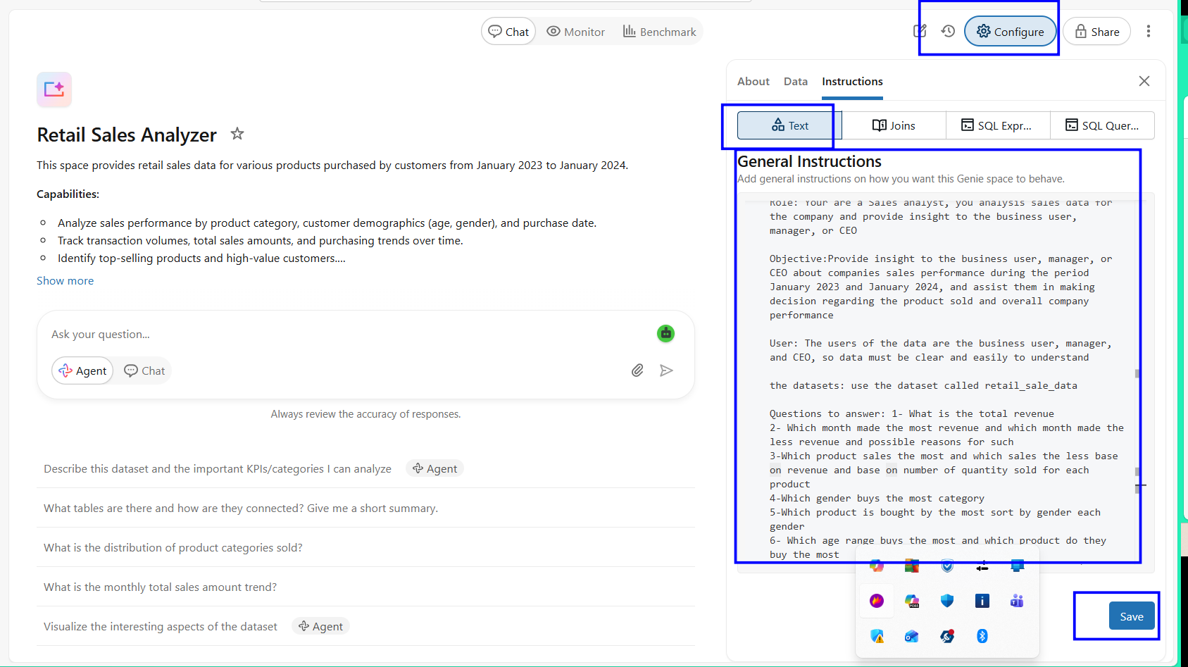

4.6 Test 10 questions
- Total revenue
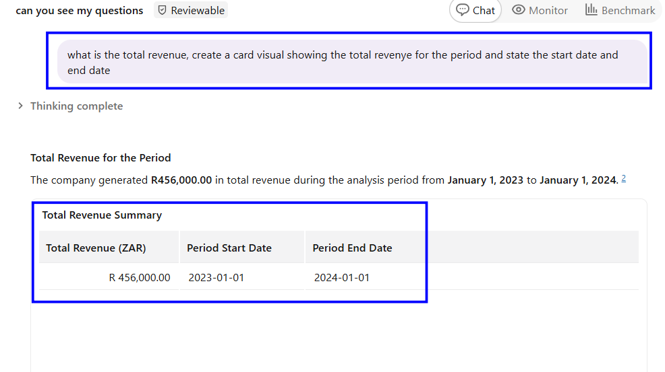
- Monthly revenue performance - highest and lowest months with possible reasons
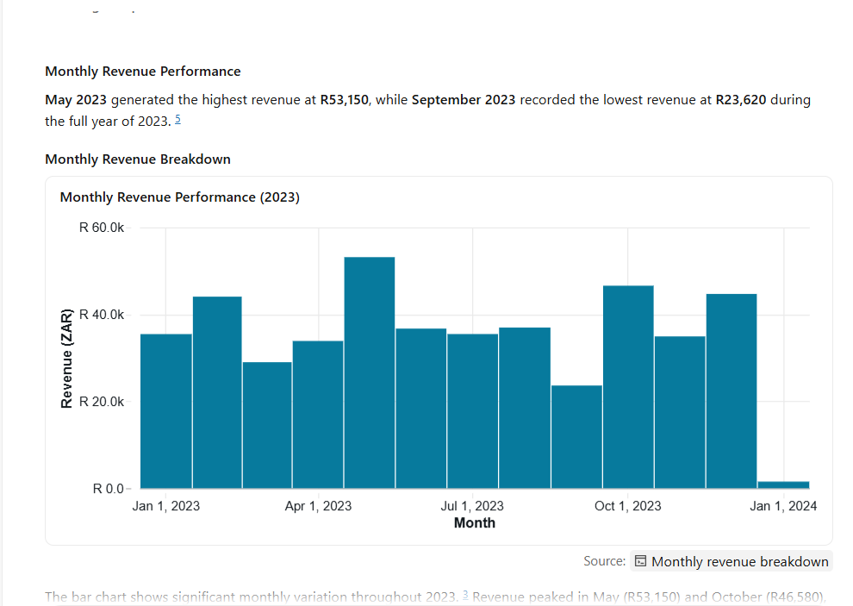

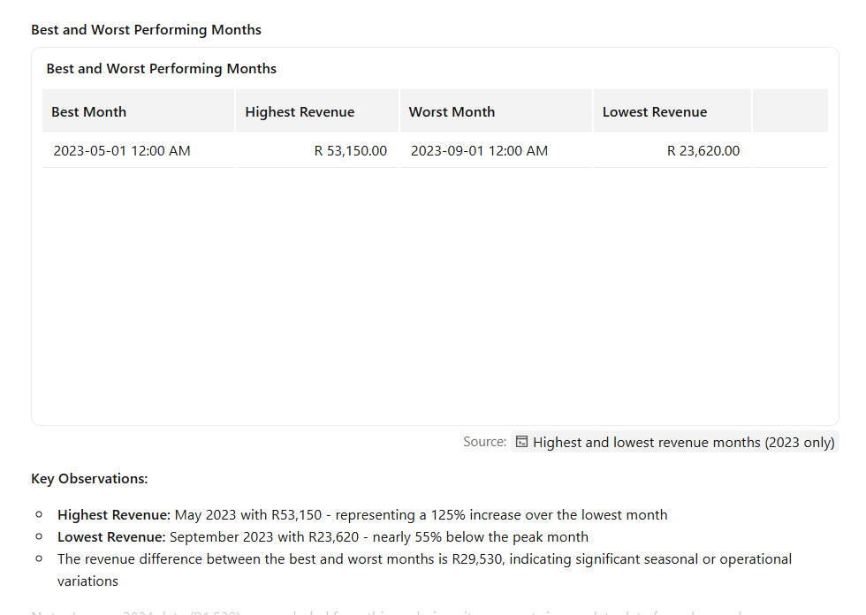
- Product performance - best and worst sellers by revenue and quantity

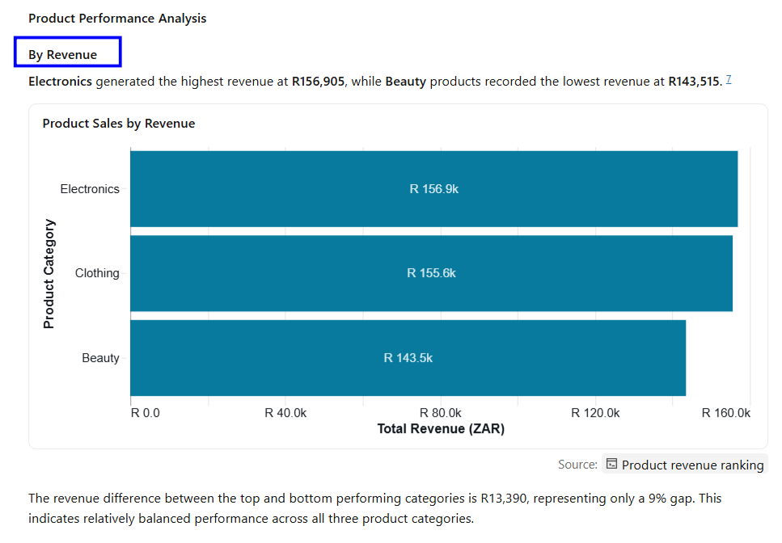
By Quantity
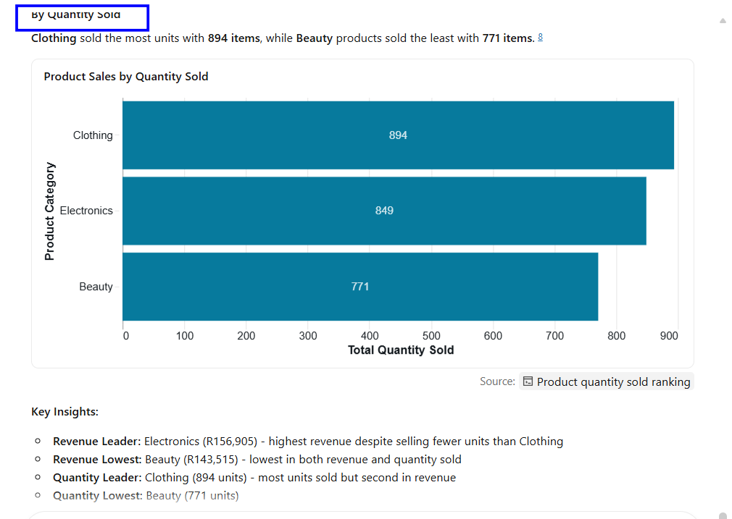

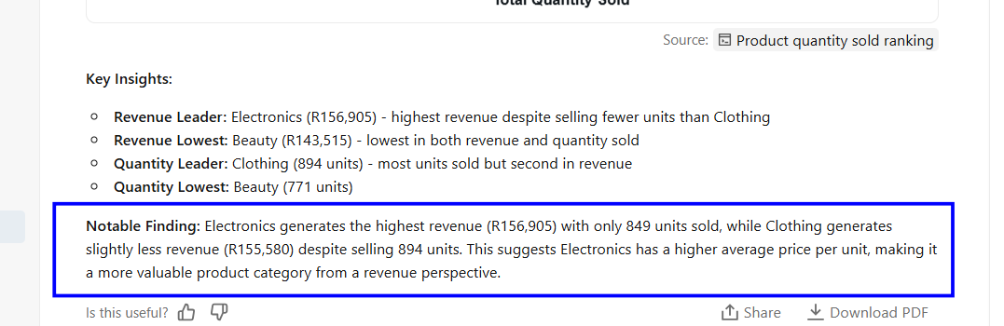
- Gender purchasing patterns - which gender buys the most of each category

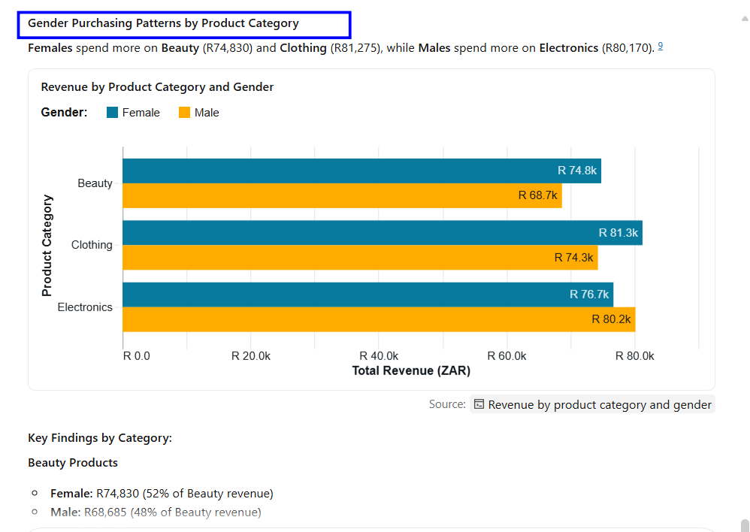

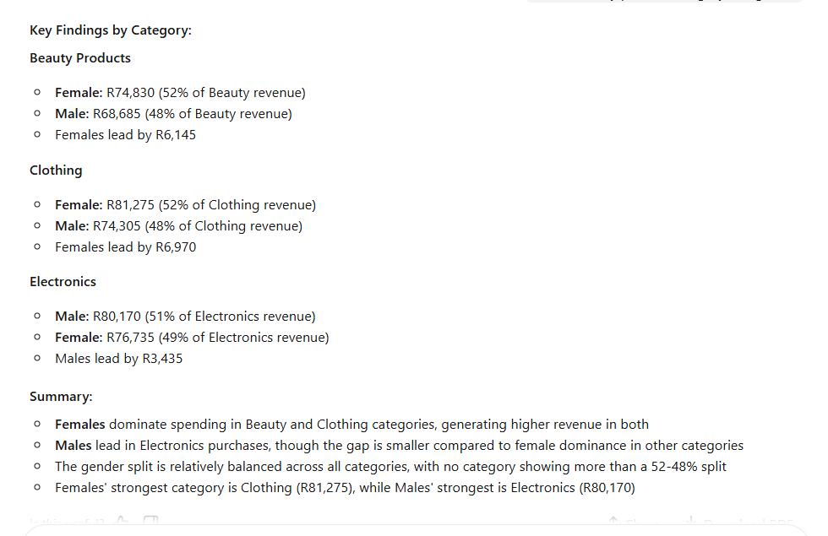
- Product preferences by gender - top products for each gender
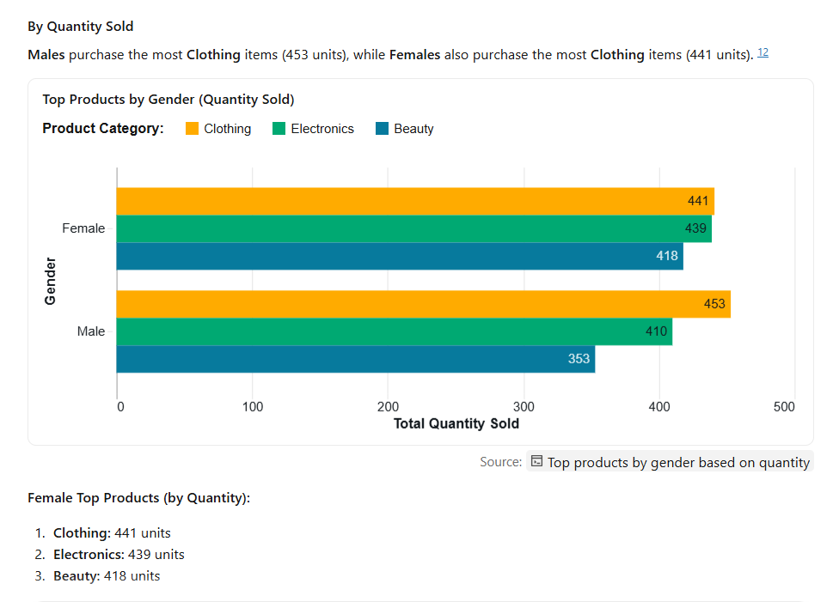

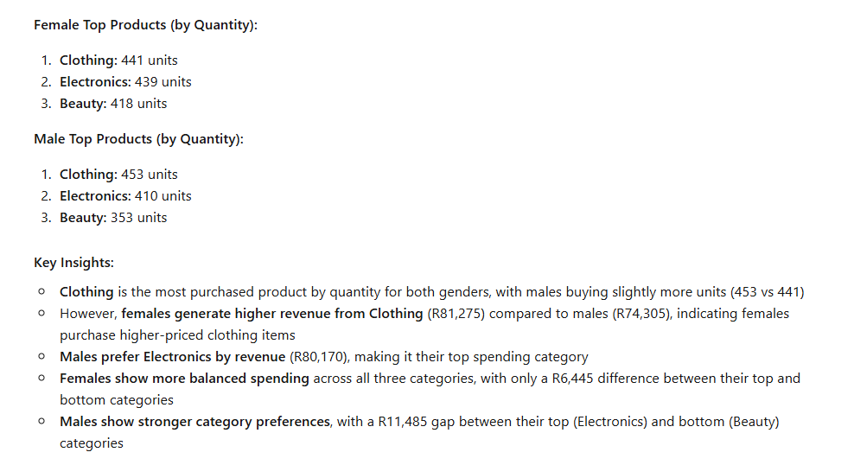
- Age range analysis - which age groups buy the most and their product preferences
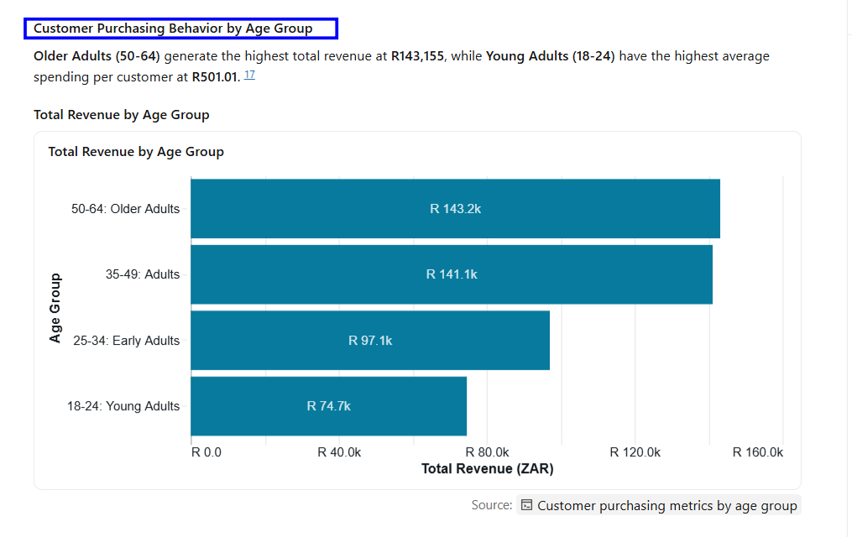
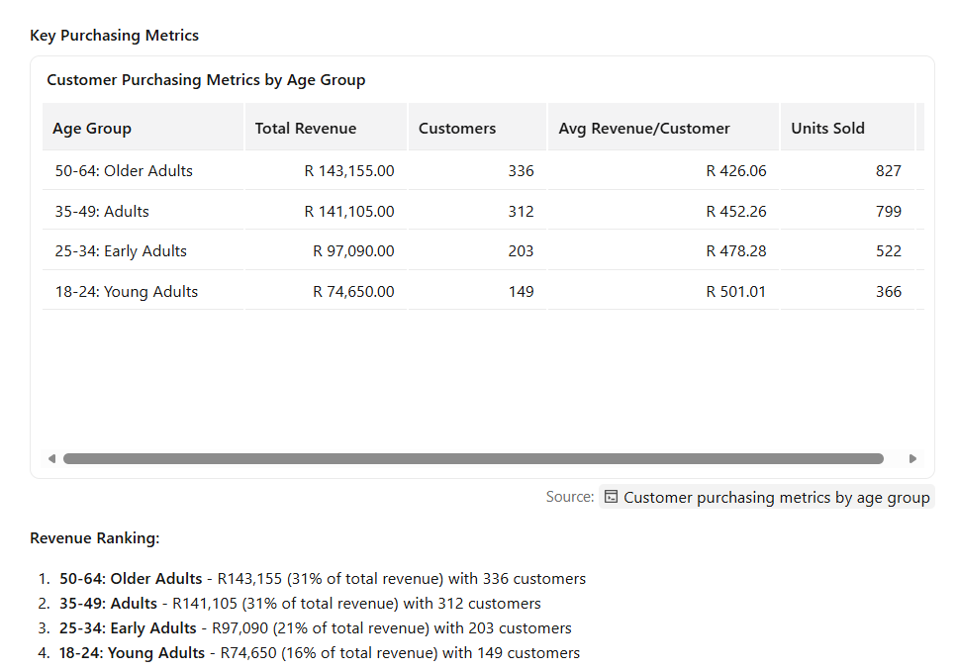
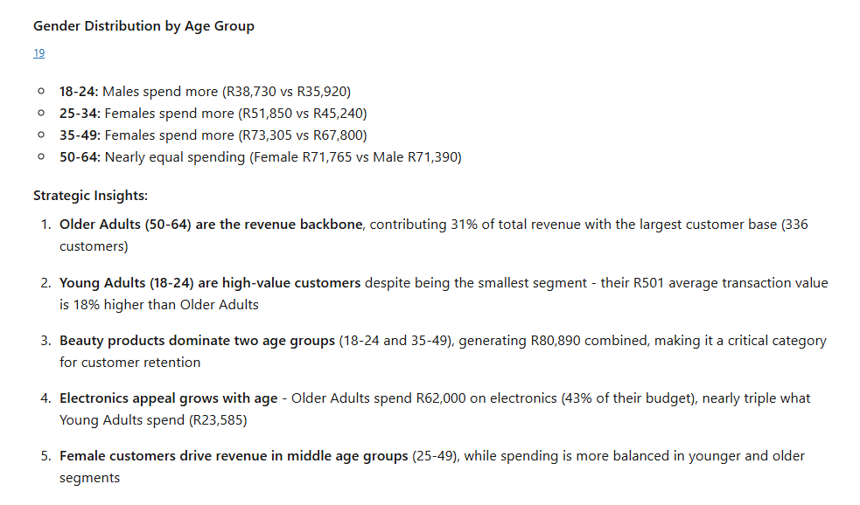
- Seasonal sales performance - revenue across summer, autumn, winter, spring
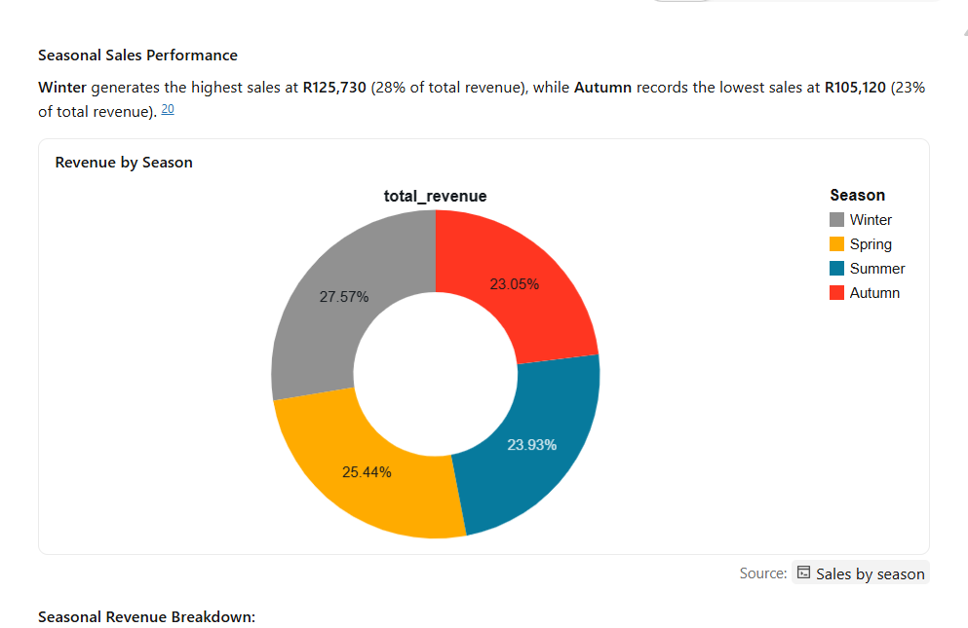
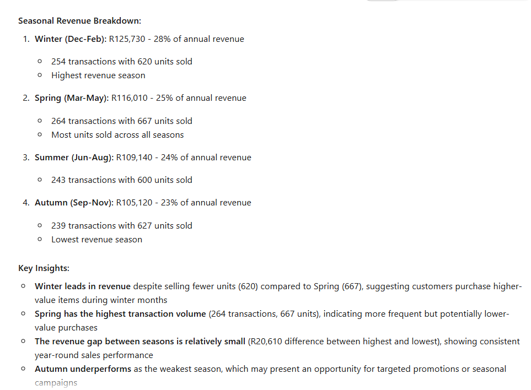
- Seasonal product trends - best and worst selling products per season
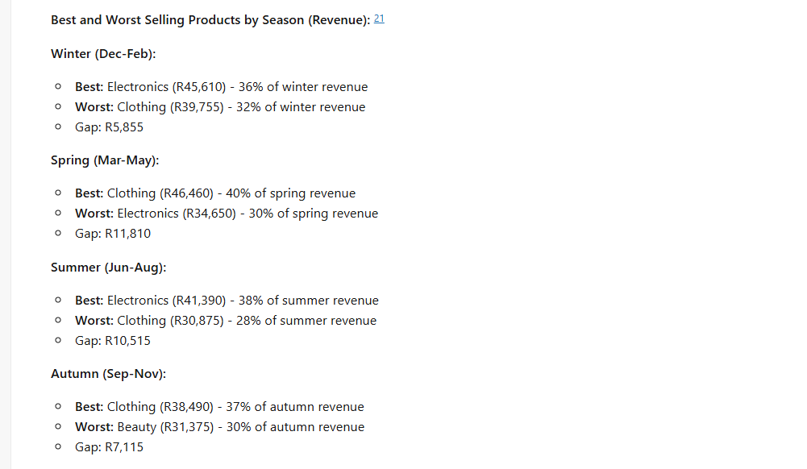

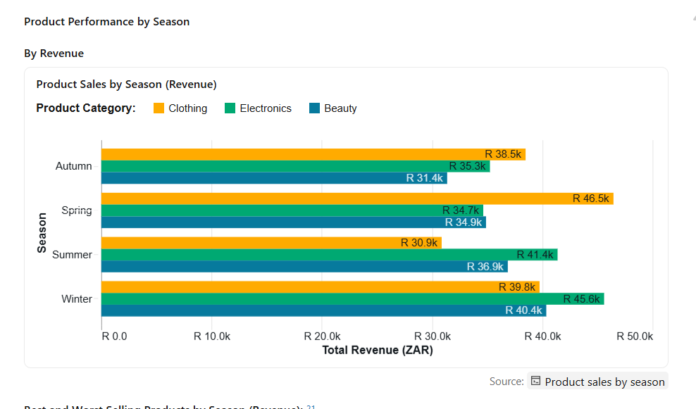

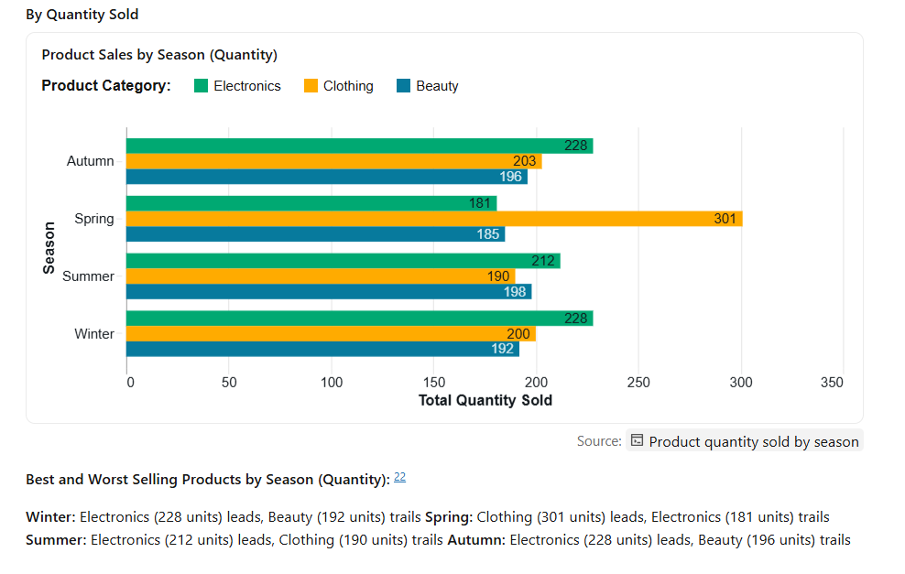
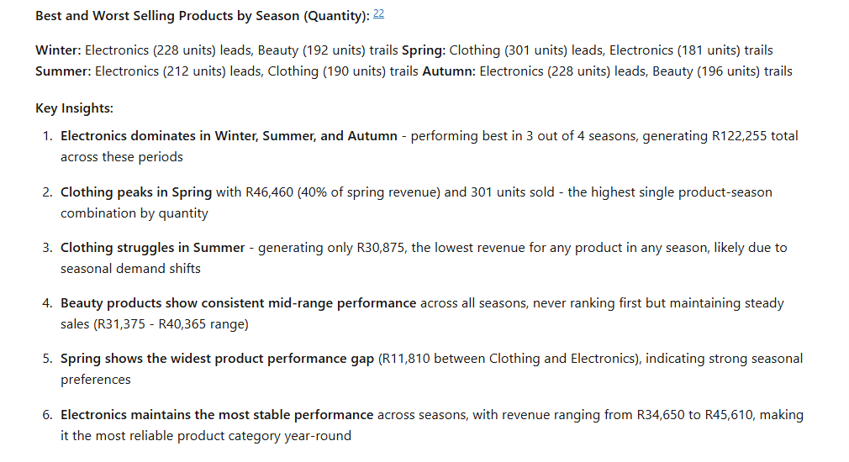
- Which days of the week generate the most sales?
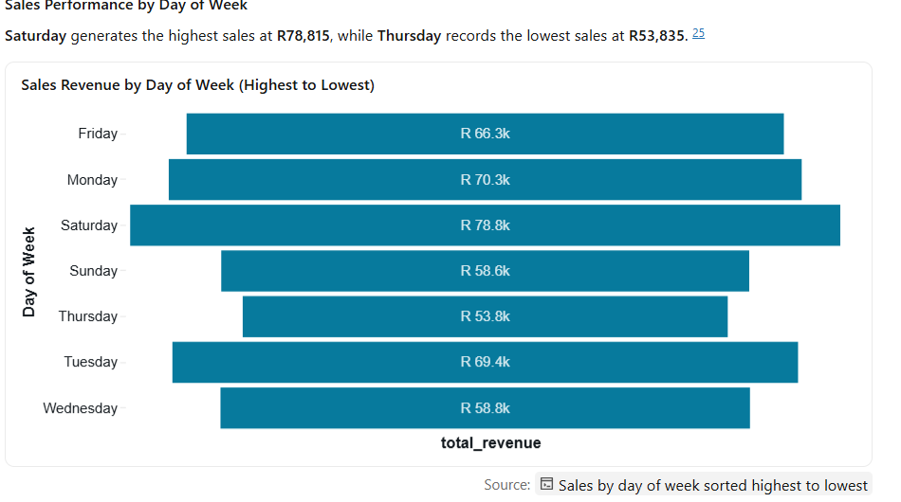

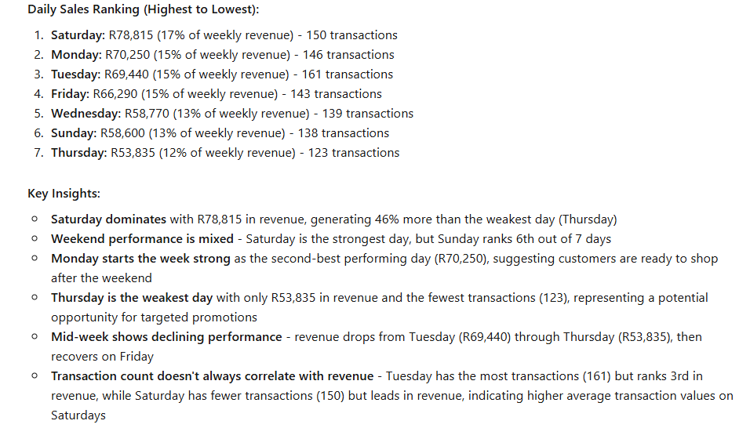
- Investment recommendations - which products the company should focus on?
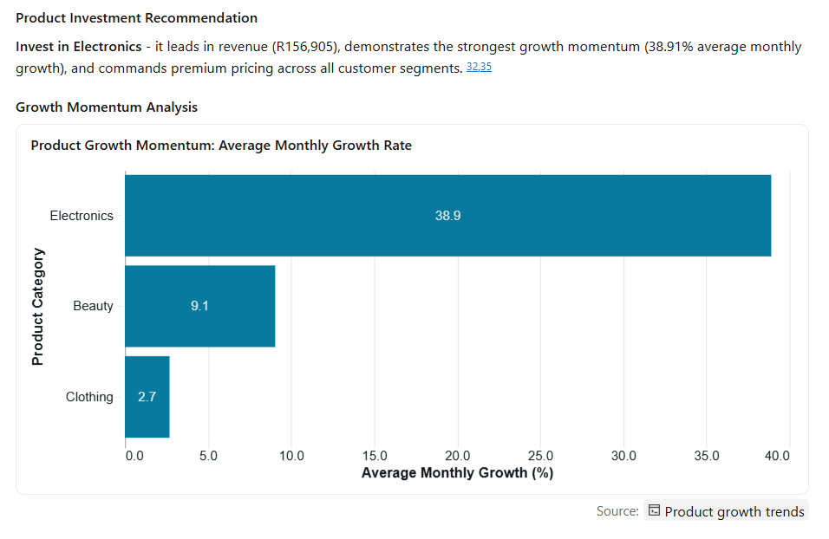

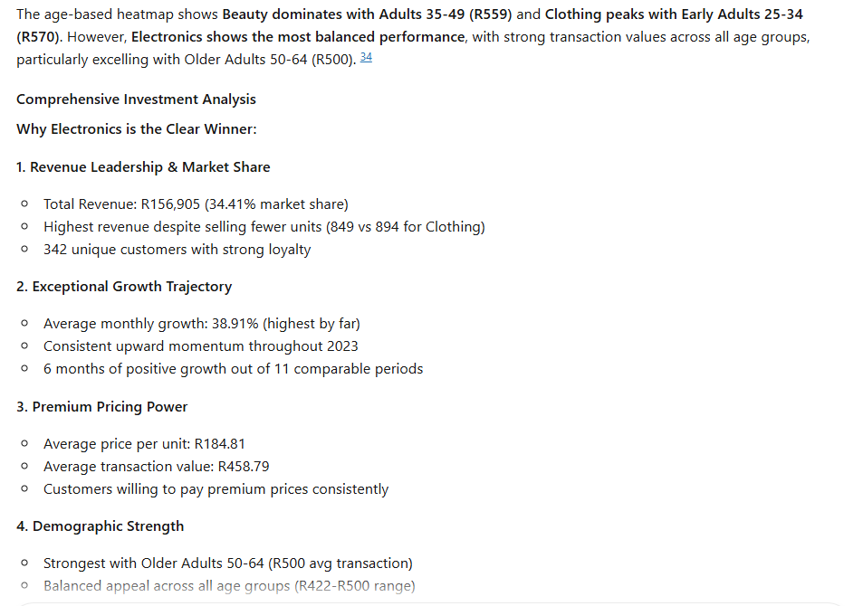
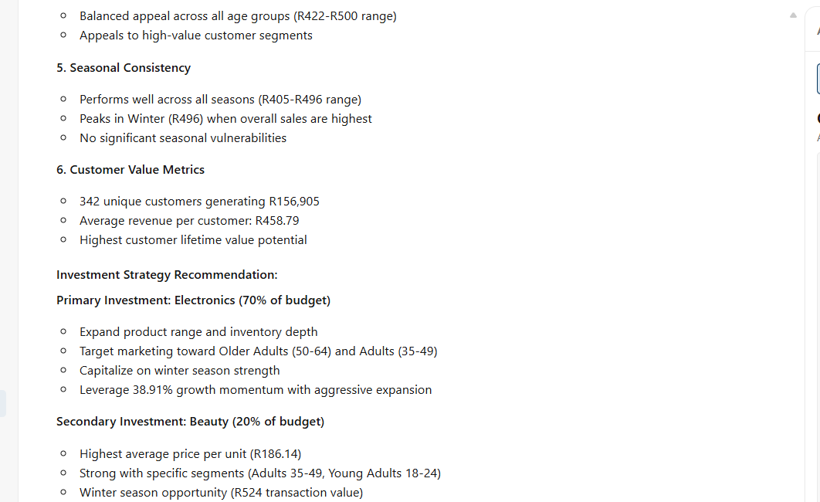

Validate the Answers
- Monthly revenue performance - highest and lowest months with possible reasons

My results
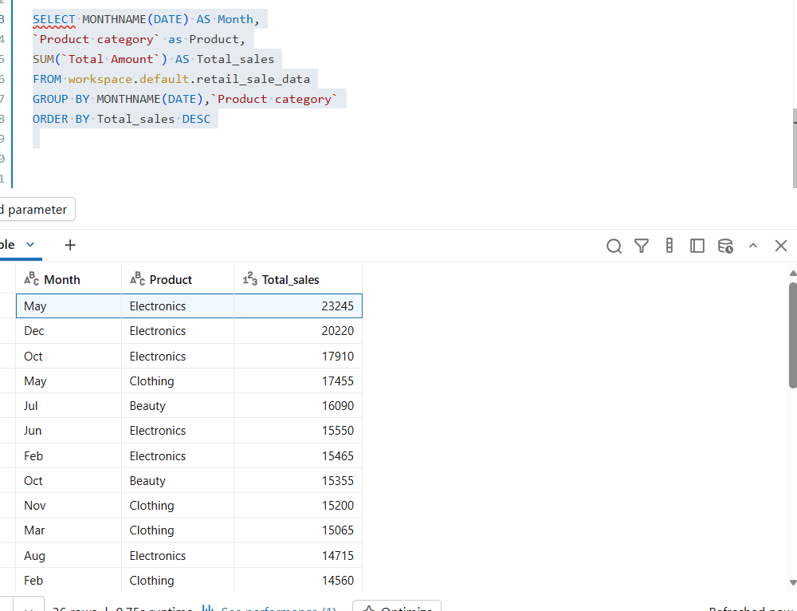

Agent results


My results are correct however I didn’t specify to the agent to group it by category aswell

7) Seasonal sales performance - revenue across summer, autumn, winter, spring

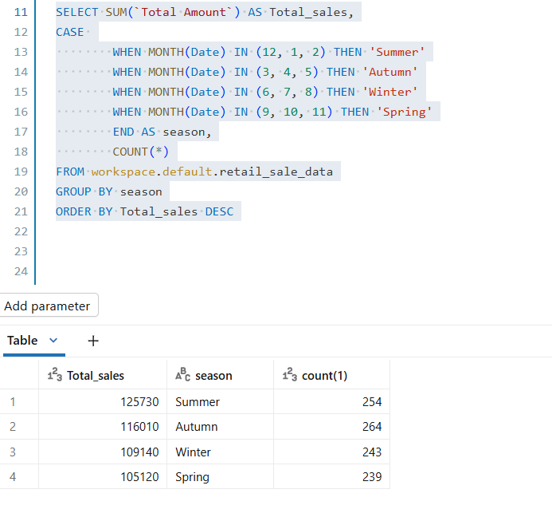
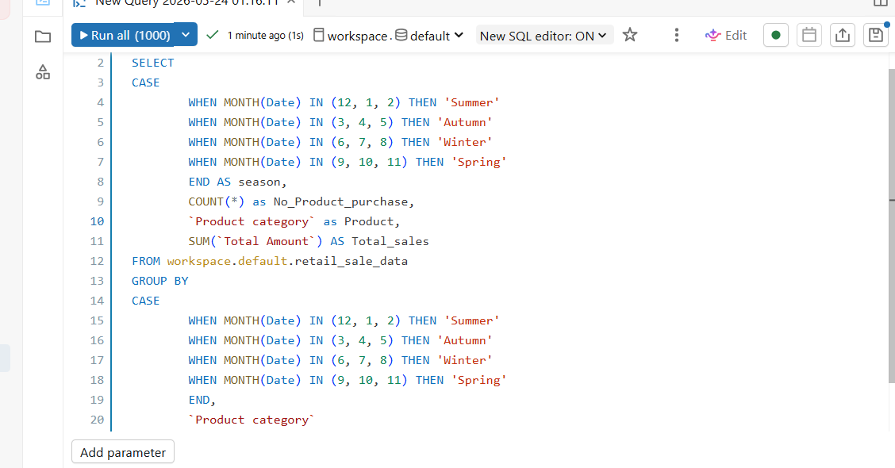
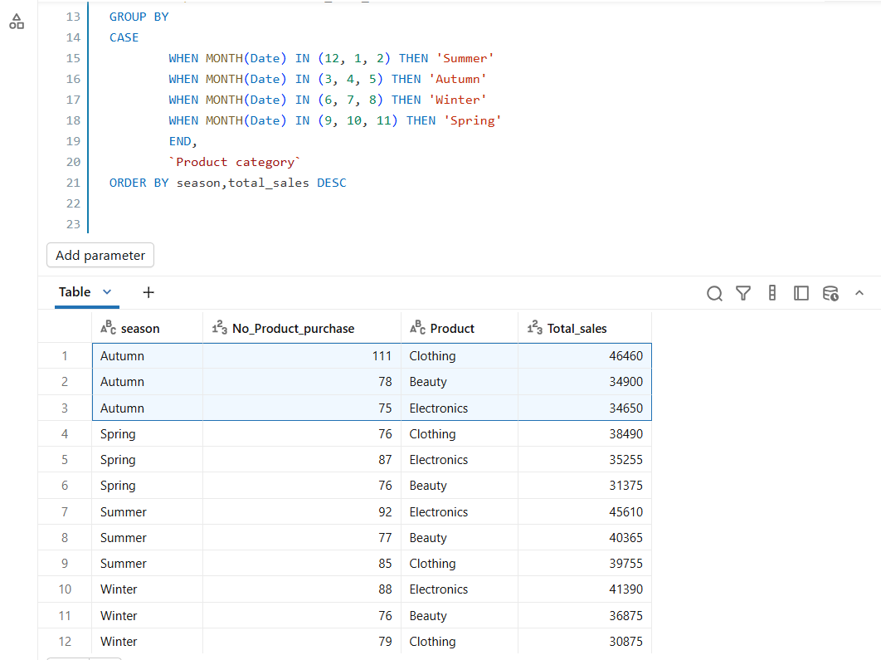

Agent results

My result are correct however I want a way to display best and worst only because sometimes you will have a lot of products to analysing them one by one might be tricky and time consuming
  - Which days of the week generate the most sales?

My SQL Query indicates that on Thursday they make the lowest Sales and on Saturday they make the highest sales
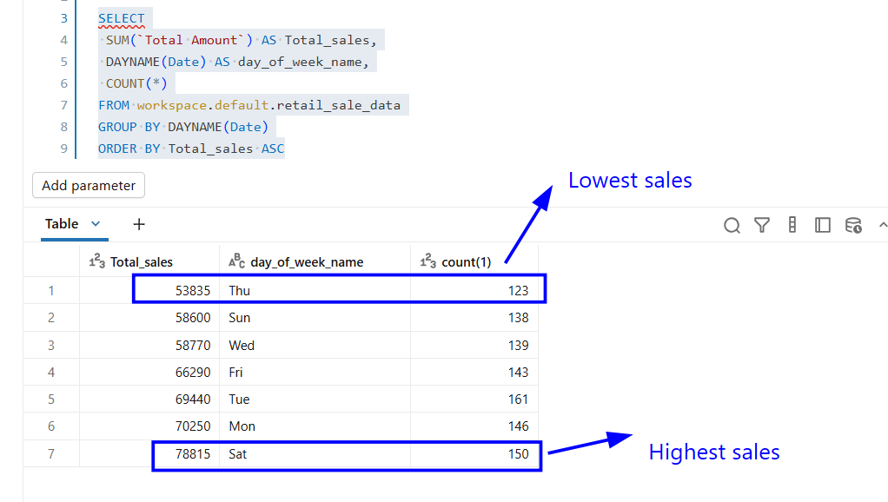
The agent’s Answer:


My answer is correct however the graph I used or recommended on the agent does not display sales from Lowest to highest, I think the instruction I gave to the agent were not clear

Business recommendations
The company generated R456,000 in revenue during 2023 with 1,000 customers and an average transaction value of R456.
5.1 Product investment
The company should invest more in electronics as it is the top selling product during the year, the company can introduce premium electronics.
  - customer segmentation strategy
The organisation should launch loyalty program to attract more customers between the age of 18 – 24 years

Conclusions
Using the agent was quite easy, although I had to instruct the agent a couple of times of what I want the output to be. The hardest part was to get my query to give me a summary of things ( e.g checking which season did we make the most sales and which product was bought the most and which was bought the least) I was unable to get what I want instead I got the entire table which can be time consuming When you are dealing with data that has a lot of information

Git hub link
Ceehle3/retail-sales-agent-analysis: AI agent for analyzing retail sales data (Jan 2023–Jan 2024)

